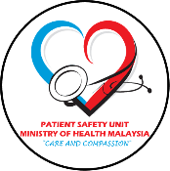

MIRCA FORMAT
INCIDENT REPORTING AND LEARNING SYSTEM
MINISTRY OF HEALTH MALAYSIA

Investigation subject:
- –
- –
- –
- –
References used
No. | Resource
1
2
3
4
5
Team members
No. | Name | Designation
1
2
3
4

Profile of Incidents investigated & Contributory causes
No. | Hospital  Reference Number | Date of Incidents | Brief summary of the incidents & the patient’s outcome | Contributory causes
1
2
3
4
5
6
7

Significant Problems identified
No. | Problem
1
2

Action Plan
No. | Problem | Action | Resources Needed | Person Responsible | Date commenced | Date review
1
2
3
4

Reported By
Name
Designation
Stamp

Verified By
Name
Designation
Stamp

